Tracking Of Medicines Over Blockchain
Chennamgari Sri Sai Nikhil
Department of Computer Science and Engineering
Anurag group of institutions, Ghatkesar, Telangana, India
Email- 17h61a0573@cvsr.ac.in

Vuppula Rahul
Department of Computer Science and Engineering
Anurag group of institutions, Ghatkesar, Telangana, India
Email- 17h61a05b8@cvsr.ac.in

Chawan Prashanth Naik
Department of Computer Science and Engineering
Anurag group of institutions, Ghatkesar, Telangana, India
Email- 17h61a0572@cvsr.ac.in

Abstract- The rise of online pharmacies is making it difficult to standardize medicine supply safety. It has become very difficult to detect whether the medicines are original or not because these drugs pass through complex distributed networks, thus forming different chances for counterfeits to enter the genuine supply chain. In this project, we are using a novel drug supply chain management using Ganache based on blockchain technology to handle secure drug supply chain records. It will act like a proof of concept which solves this problem by performing drug record transactions on the blockchain to create a smart healthcare system with a drug supply chain. Generally a smart contract is launched to give a time-limited access to electronic drug records. Finally, we used blockchain smart contracts as a benchmarking programs to conduct the performance of the designed system in terms of transactions per second, transaction latency, and resource utilization.

I. Introduction
The pharmaceutical industry is the bit of the healthcare sector that deals with medications. The industry includes various sub-fields related to drug development, production and marketing. The primary goal of the pharmaceutical industry is to provide drugs that prevent infection, maintain health and treat diseases. The supply chain of the pharmaceutical industry is like a supply chain for any other industry in the manufacturing sector. In addition, the associated information flows through the relationships in the supply chain to achieve sustainable competitive advantage. Pharmaceutical supply chain management is more difficult than typical applications within industrial companies, as medicines and surgical supplies must be available for use at all times. As the complexity of the supply chain becomes more important than it was a decade ago, visibility of inaccessible, reliable, and secure supply chains is becoming increasingly important. And also this increasing complexity effect the cost of drugs and their availability to consumers.
The advancement of information systems and the introduction of blockchain technology has converted the traditional drug supply chain approach in healthcare into a secure automated systems. To enable a software platform to be used without a trusted third party, one of the possibilities is to use smart contracts. One of the latest platforms is open-source Ganache, a modular system that uses conventional programming languages for smart contracts.

II. Proposed Algorithm

2.1 Using Smartcontract using solidity programming –
The great features of blockchain technology that is helpful in traceability, security, transparency. A blockchain-based system is inserted to provide a secure decentralized tracking system. System architecture relies on the Ethereum blockchain and smart contracts to remove the need for third-party system management. The application consists of a smart contract for Ethereum, which contains the processes of the supply chain, in addition, it has provided the ability to store and retrieve records from the blockchain ledger, which makes it easy to track the product and ensure that the data cannot be changed. We create and integrate a local blockchain(by Ganache) then link the Ethereum wallet to the application using MetaMask, so it forms a transaction bridge. This involves the ordering of transactions or of medication. Solidity’s programming code is basically encapsulated in contracts that is a contract in Solidity is a collection of code and its data that reside at a particular address in the ethereum blockchain. A contract means it is generally a fundamental block of building an app on ethereum.
2.2 QR code based tracking-
The Medicine manufacturer will store the data in the form of smart contracts and will generate unique QR code for each medicine and will attach it to the label of the medicine. This information of medicine is retrieved by the consumer and supplier by scanning the QR code and check the details from where the medicine is came from and its information like manufacturer date and expiry date. This is introduce to make sure that most of the medicines are just imitating the printing of the label and selling the duplicate drugs instead. By using this method we can put a check to these people.
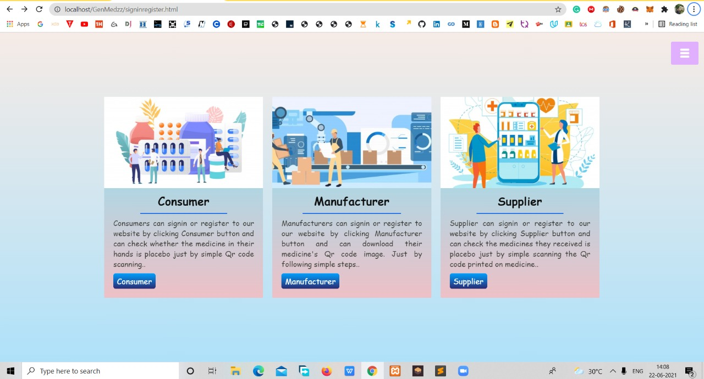
Fig. 2.1 user interface for manufacturer, supplier and consumer to login

III. Experiment and Result
3.1 Code involved in the solidity programming-
Main.sol
pragma solidity ^0.5.16;
import "../medicineaccess/Roles.sol";
import "../medicineaccess/DistributorRole.sol";
import "../medicineaccess/ManufacturerRole.sol";
import "../medicineaccess/UserRole.sol";
import "../medicinecore/ownable.sol";
contract main is UserRole, ManufacturerRole, DistributorRole {
// Define 'owner'
address owner;
// Define a variable called 'batchno' for unique authentication
string batchno;
// Define a public mapping 'medicines' that maps the batchno to an Medicine.
mapping (string => Medicine) medicines;
// Define a public mapping 'medicinesHistory' that maps the UPC to an array of TxHash,
// that track its journey through the supply chain -- to be sent from DApp.
mapping (string => string[]) medicinesHistory;
// Define enum 'State' with the following values:
enum State
{
Made, // 0
Packed, // 1
Sold // 2
}
State constant defaultState = State.Made;
// Define a struct 'Medicine' with the following fields:
struct Medicine {
string batchno; //the primary key batchno
string medicineName; //Medicine name
string dosage;//dosage
address ownerID; // Metamask-Ethereum address of the current owner as the medicine moves through 3 stages
address originManufacturerID; // Metamask-Ethereum address of the Manufacturer
string FactoryName; // Manufacturer Name
string mfgdate;//mfgdate
string expdate; // expdate
State medicineState; // Product State as represented in the enum above
address distributorID; // Metamask-Ethereum address of the Distributor
address userID; // Metamask-Ethereum address of the user
}
// Define 8 events with the same 7 state values and accept 'batchno' as input argument
event Made(string _batchno);
event Packed(string _batchno);
event Sold(string _batchno);
// Define a modifer that checks to see if msg.sender == owner of the contract
modifier onlyOwner() {
require(msg.sender == owner);
_;
}
// Define a function 'makeMedicine' that allows a manufacturer to mark a medicine 'Made'
function makeMedicine(string memory _batchno, string memory _medicineName,string memory _dosage, address _originManufacturerID,address _ownerID, string memory _FactoryName, string memory _mfgdate,string memory _expdate,State,address _distributorID,address _userID) public onlyManufacturer
{
// Add the new medicine as part of medicines
Medicine memory makeMedicine = Medicine({
batchno:_batchno,
medicineName:_medicineName,
dosage:_dosage,
originManufacturerID:_originManufacturerID,// Metamask-Ethereum address of the Manufacturer
ownerID:_ownerID, // Metamask-Ethereum address of the current owner as the medicine moves through 3 stages
FactoryName:_FactoryName, // Manufacturer Name
mfgdate:_mfgdate,//mfgdate
expdate:_expdate,//expdate
medicineState: State.Made,
distributorID: _distributorID,
userID: _userID
});
medicines[_batchno] = makeMedicine;
medicines[_batchno].medicineState = State.Made;
// string batchno;//batchno
// address ownerID; // Metamask-Ethereum address of the current owner as the medicine moves through 8 stages
// address originManufacturerID; // Metamask-Ethereum address of the Manufacturer
// string FactoryName; // Manufacturer Name
// string medicineName; // Product Name
// string mfgdate//mfgdate
// string expdate//expdate
// State medicineState; // Product State as represented in the enum above
// address distributorID; // Metamask-Ethereum address of the Distributor
// address userID; // Metamask-Ethereum address of the Patient
// Emit the appropriate event
emit Made(_batchno);
}
// Define a function 'packMedicine' that allows a manufacturer to mark an medicine 'Packed'
function packMedicine(string memory _batchno) public
onlyDistributor
// Call modifier to check if batchno has passed previous supply chain stage
//Made(_batchno)
// Call modifier to verify caller of this function
{
// Update the appropriate fields
medicines[_batchno].medicineState = State.Packed;

// Emit the appropriate event
emit Packed(_batchno);
}
function receiveMedicine(string memory _batchno) public
onlyUser
// Call modifier to check if batchno has passed previous supply chain stage

function fetchMedicineBufferTwo(string memory _batchno) public view returns
(
string memory batchno, //the primary key batchno
address distributorID,
address userID
)
{
// Assign values to the 7 parameters
return
(
medicines[_batchno].batchno,
//medicines[_batchno].medicineName,
//medicines[_batchno].ownerID,
//medicines[_batchno].originManufacturerID,
//medicines[_batchno].medicineState,
medicines[_batchno].distributorID,
medicines[_batchno].userID
// medicines[_batchno].
);
}
}
origOwner = newOwner }}

3.2 Backend development environment for the proposed drug supply chain management in a medical blockchain platform.
Component Description :
- IDE-Visual Studio
- Truffle suite-Ganache
- Smart contracts-solidity programming
- Node JS 14.17.2 TLS
- Metamask
- CPU Intel(R) Core(TM) i5-8500 CPU @ 3.00GHz 3.00 GHz
- Operating Systems Windows 10
- Memory 8 GB
3.3 In the Front end development for the proposed system
- Component Description :
- Programming Language: HTML, CSS, JavaScript
- Operating System: Windows 10 64 bit
- Browser: Google Chrome, Microsoft Edge, Firefox
- Library and Framework: Bootstrap, jQuery
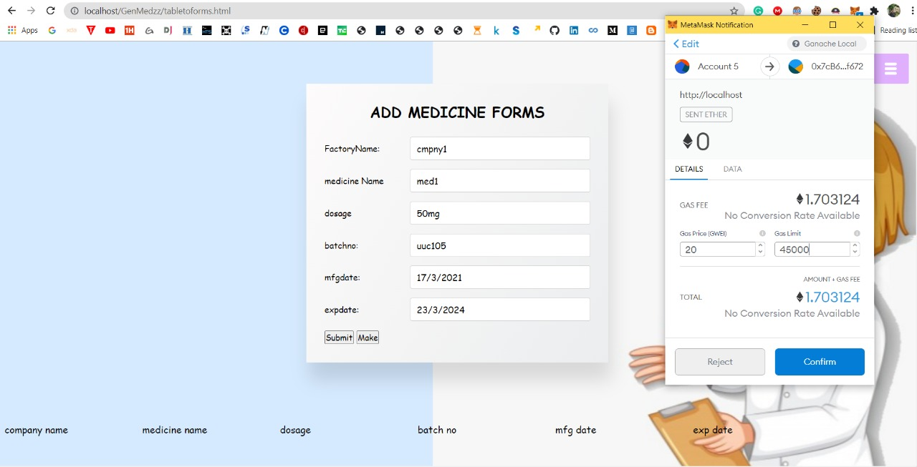
Fig 3.1 The manufacturer add medicine details and do transaction in metamask

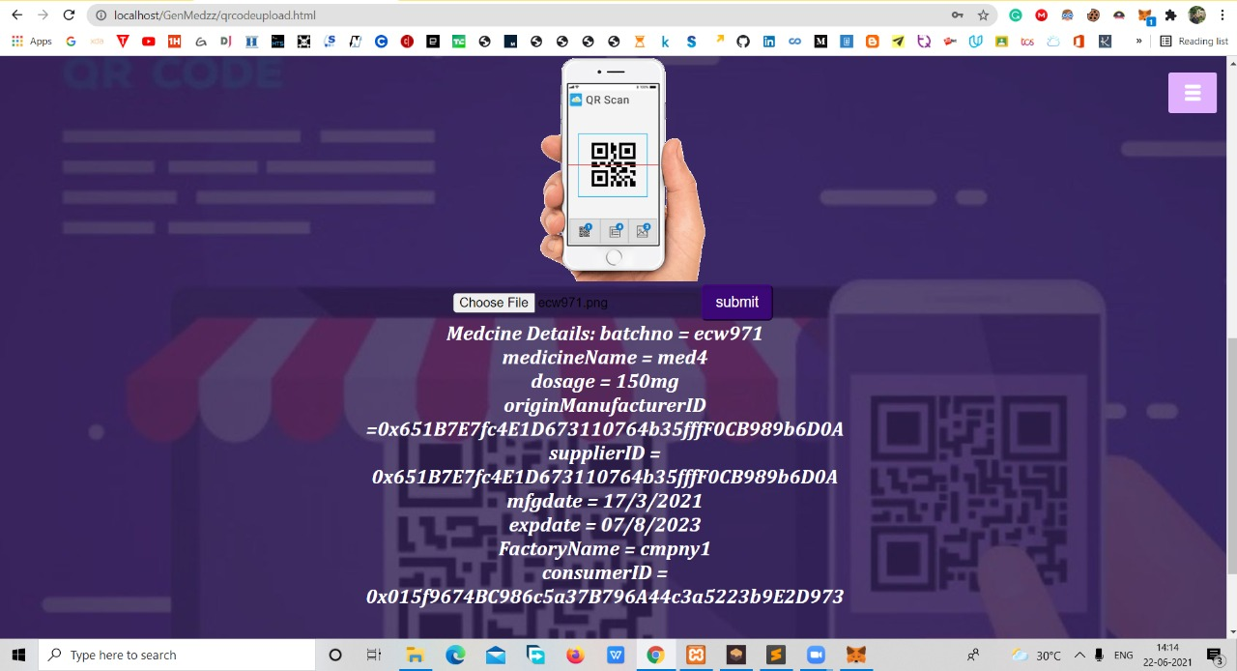
Fig. 3.2. the details of the medicines are retrieved after the scanning of the qr code

IV.CONCLUSION
Generally these supply chain operations are very complex and it require very extensive management. The effective use of contract logistics services places companies in an advantageous position in terms of chain management and agreement of their distribution operations. Drug Supply chain challenges constitute an obstacle in the pharmaceutical supply chain system, the risk of fraud and falsifying in traditional systems is significantly high. It needs a well-designed and reliable platform and a way to implement and use this basic system. Drug manufacturers and distributors should consider using a platform aggregation program to address these challenges and simplify the supply chain. Since the beginning of the digital age, organizations have been looking for improvements to their current business structure and significantly provide communication and transparency along the drug supply chain through modernisation and the emergence of new technologies. Blockchain is a digital technology that is able to support current processes and disable complex models. The technology makes the process paperless that all the involved parties may interact with each other by using public and private keys. Industries can gain the advantage by adopting the technology into their business, it provides the necessary connectivity, increased security and full transparency to make the supply chain vision come true. In this chapter, we will suggest a new simple drug supply chain system using Blockchain technology to handle secure drug supply chain records. The proposed system solves this problem by recording transactions of supply chain processes on a Blockchain basis to create an intelligent ecosystem to reduce the challenges and problems faced by the pharmaceutical supply chain. It is a fact that healthcare at present needs to have more attention to secure the medicines and they need to make sure that their medicines are used in an authentic way, blockchain in healthcare is the near future. Managing electronic health records in blockchain could have few focal points. The potential assistance of blockchain for researchers is that it could provide verified and timestamped versions of scientific studies. Just like the smart contracts allow patients to regulate their data, a documentation blockchain record would allow researchers to possess a sustainable history of their findings. Basically in this field of the pharmaceutical industry, blockchain is much needed technology.

REFERENCES
[1] Supply chain 4.0. white paper. http://www3.weforum.org/docs/WEF_Supply_ Chain_4.0_2019_Report.pdf.
[2] What is meant by supply chain management process, https://www. predictiveanalyticstoday.com/supply-chain-management-process/.
[3] Cryptography in the blockchain technology: Types & applications [2020]. https://www. upgrad.com/blog/cryptography-in-blockchain/, (Accessed August 1. 2020).
[4] React, react a javascript library for building user interfaces, https://reactjs. org/.
[5] Expres 4.17.1 fast, minimalist web framework for node.js. www.expressjs.com/.
[6] MongoDB. https://www.mongodb.com/what-is-mongodb
[7] Understanding public vs. private blockchain. https://selfkey.org/ understanding-pub.blic-vs-private-blockchain/.
[8] P2p network. https://www.vocal.com/video/p2p-network/, (Accessed December 23, 2019).
[9] The go programming language. https://golang.org.
[10] How to generate the bitcoin address in step by step process. https://medium.com/coinmonks/ how-to-generate-a-bitcoin-address-step-by-step-9d7fcbf1ad0b.
[11] Hyperledger, advancing business blockchain adoption through global open source collaboration. https://www.hyperledger.org. Cachin, C. Architecture of the hyperledger blockchain fabric.
[12] Technology, P. Blockchain in the Pharma industry: Opportunities in the supply Chain management. 2017. Available online: https://www.pharmaceutical-technology.com/digital-disruption/blockchain/blockchain-pharmaopportunities-supply-chain/
[13] Pilkington, M. 11 Blockchain technology: Principles and applications.

